n

step by step process for developing taxpayer web ApPLICATION

**Contents**

**Necessary Software Applications** 2

**CREATE THE UI** 3

*Install Bootstrap* 3

*Create HTML pages* 3

**DEVELOP BACK END** 4

*Choose a Language* 4

*Inherit Parameters* 4

*Link the PHP code* 4

*Setup PDO for API Interaction* 4

**API INTEGRATION** 5

*Install Postman* 5

*Test API functions using POSTMAN* 5

*Integrate code into system* 5

The solution created is a web application that consumes a predefined API. The systems functions can be split into three main categories:

1. Creating the UI (Front End)
2. Coding the Systems Functions (Back End)
3. API integration

**Necessary Software Applications:**

**Text Editor (**preferably Sublime Text**)** – The chosen.

**POSTMAN** – To test the API functions.

**WampServer** – To run the PHP code

**Browser** (preferably chrome) – To test the web application.

**Postman** – API testing.

# **CREATE THE UI**

**Applications to be used**:

Sublime Text and Browser.

**Approximate percentage of time to be spent:**

20%

## *Install Bootstrap*

The front-end or the UI is powered by the popular **Bootstrap** which eases coding lines and make use of grids for appropriate position of elements. The bootstrap file can be downloaded and linked into the CSS with ease. More information can be found on the website <https://getbootstrap.com/>.

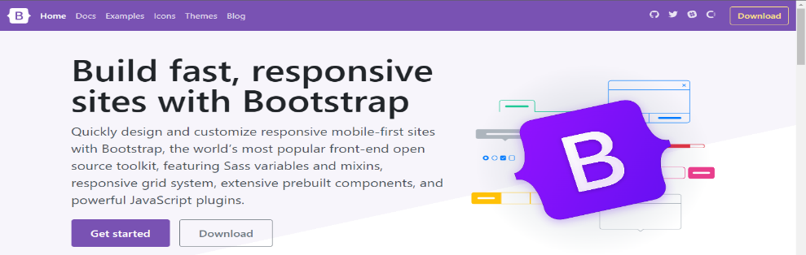

## *Create HTML pages*

The HTML pages will be created to compliment the system as they contain forms and links that led to the linked pages. HTML elements should be used with appropriate scenarios to ease integration.

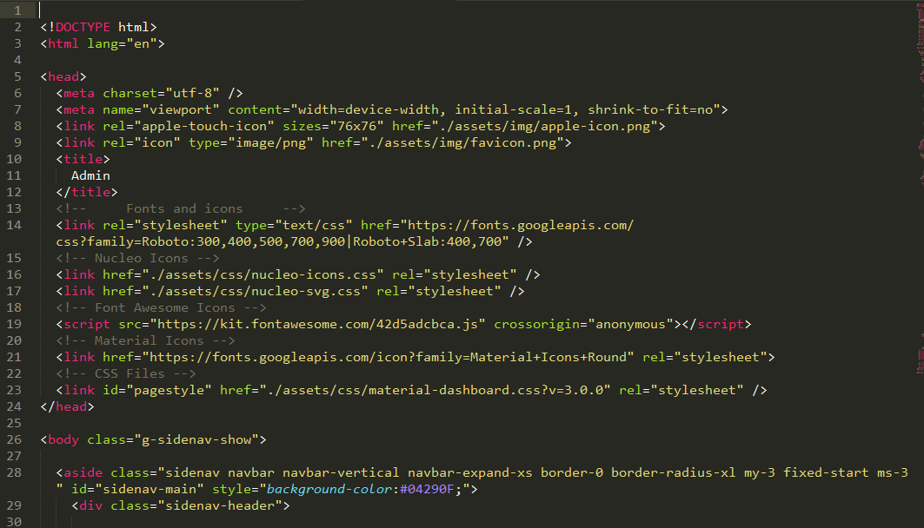

# **DEVELOP BACK END**

**Applications to be used**:

Sublime Text, Browser and WampServer.

**Approximate percentage of time to be spent**:

40%

## *Choose a Language*

The backend of the system was coded in server-sided language PHP. The PHP code effortlessly communicates with data passed through HTML variables.

## *Inherit Parameters using chosen Language*

The PHP code will have to inherit and manipulate values taken from HTML elements. Write PHP code that stores the necessary values and appropriate variable names. PHP code will be written to help with validation of values. This deals with securing information and preventing SQL injection and other problems.

## *Link the PHP code*

PHP code can either be integrated into the html data or can either be called upon. The next step is integration of the HTML and PHP ready for execution of called upon functions. These functions will be called from the provided API and as such will push the decision of using PDO.

## *Setup PDO for API Interaction*

PHP Data Objects (PDO) is the object-oriented section of PHP and is the most viable method used for collection variables from APIs as they usually pass their values as objects and secures the code from SQL Injection. For further study of PDO refer to the website: <https://www.javatpoint.com/php-pdo>.

# **API INTEGRATION**

**Applications to be used**:

Postman, Sublime Text, Browser

**Approximate percentage of time to be spent**:

40%

## *Install Postman*

Postman will be used for the testing of the different API calls. Postman will ease the process of testing as it is user friendly and runs different flavors of code that one can pick from. The postman link is pasted here:



## *Test API functions using POSTMAN*

The various API calls will be tested in accordance to the type of request, e.g., ‘POST’ ‘GET’ and it will provide the request result in accordance. For this example, we are taking the ‘POST’ function which will have login credentials checked as written below:

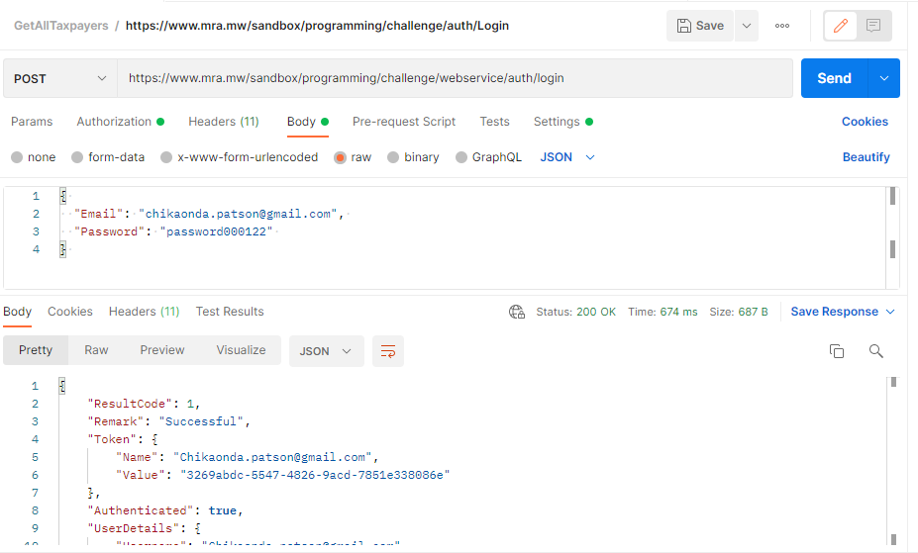

## ***Choose Flavor of Code***

When the code is executed, POSTMAN assists in the code flavors according to user preference. Below is a screenshot of the executed code and the different flavors that are offered.

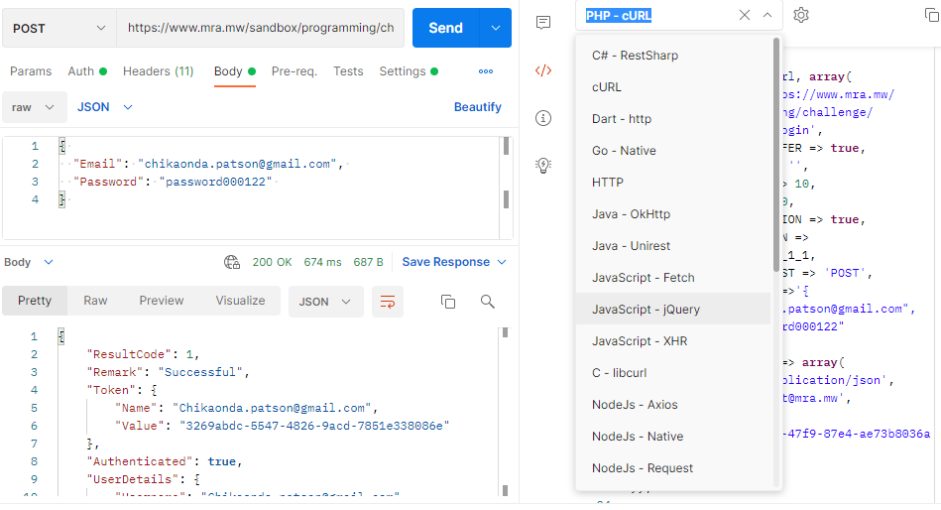

**Below is a screenshot of the preferred PHP cUrl code.**

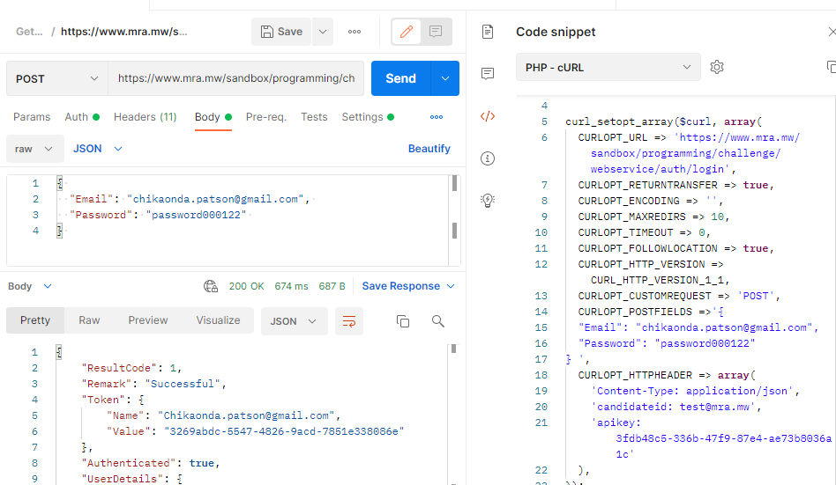

## ***Integrate code into system***

Lastly, integrate the code pasted into your system as shown in the screenshot below by accepting variables from the html forms.

